Heart Disease Prediction Using Machine Learning

Sarika Thumbapura Arun
MPS in Data Science
University of Maryland, Baltimore County (UMBC)
Baltimore, USA
sarikat1@umbc.edu

Shilpa Varadaraju
MS in Engineering Management
University of Maryland, Baltimore County (UMBC)
Baltimore, USA
shilpav1@umbc.edu
Madhurima Mukhopadhyay
MPS in Data Science
University of Maryland, Baltimore County (UMBC)
Baltimore, USA
madhurm2@umbc.edu

Sinchana Datta Pushpa Datta
MS in Engineering Management
University of Maryland, Baltimore County (UMBC)
Baltimore, USA
sinchap1@umbc.edu

Introduction
Heart disease is a major health concern worldwide, hence identifying the factors that might influence heart disease is important to help early prevention. In this project, we have considered the Heart Disease Dataset by David Lapp (Kaggle) to explore the features such as age, cholesterol, blood pressure, and other health indicators to gain meaningful insights.

BACKGROUND
Heart disease continues to represent a significant global health burden, ranking as one of the leading causes of mortality and morbidity worldwide. The multifactorial nature of heart disease, influenced by a combination of age, blood pressure, cholesterol levels, lifestyle behaviors, and genetic predisposition, complicates early detection and effective prevention efforts. Accurate identification of at-risk individuals is critical in reducing the prevalence and improving clinical outcomes of the disease. In recent years, the growing availability of healthcare datasets and advances in computational power have catalyzed the adoption of machine learning techniques for cardiovascular risk prediction. These approaches enable automatic analysis of high-dimensional and complex data, uncovering latent patterns that may be overlooked. Among various machine learning algorithms, logistic regression is widely favored in medical applications for its simplicity, interpretability, and effectiveness in binary classification tasks such as predicting the presence or absence of heart disease.
This study leverages logistic regression to analyze key features extracted from an established Heart Disease Dataset (sourced from David Lapp on Kaggle), including clinical indicators like age, cholesterol, and blood pressure. By rigorously modeling the relationships between these variables, the research aims to improve predictive performance and provide a transparent risk assessment tool that can assist clinicians in making timely and informed decisions. The integration of machine learning into heart disease prediction holds promise for enhancing preventive healthcare frameworks and ultimately mitigating the global burden of cardiovascular conditions

Related Work
- Hamad and Rashid (2025) utilized the LPBSA-MLP model, which integrates a multilayer perceptron (MLP) neural network with a metaheuristic optimization technique. The study achieved exceptionally high predictive accuracy; however, the model’s complexity and limited interpretability were identified as key drawbacks, reducing its practical applicability in real-world decision-making contexts.
- Başar et al. (2025) proposed a hybrid framework combining an Artificial Neural Network (ANN) with Principal Component Analysis (PCA) and SHAP (SHapley Additive exPlanations) methods, applied to a dataset of 13,981 patients. Their approach demonstrated strong specificity, indicating reliable identification of negative cases. Nonetheless, the model exhibited relatively low sensitivity, suggesting a tendency to overlook true positive instances, which could undermine diagnostic reliability.
- Narain et al. (2023) conducted a comparative analysis of several machine learning models, including Random Forest (RF), Decision Tree (DT), Multilayer Perceptron (MLP), and XGBoost, using a dataset obtained from Kaggle. While the study provided valuable insights into model performance variations, it was limited by its reliance on a single dataset, thereby constraining the generalizability of the findings across broader populations.
- Clarite and Palma (2022) implemented a Decision Tree model using MATLAB to analyze their data. Although the model yielded interpretable results, it suffered from overfitting issues, largely attributed to the limited size and diversity of the dataset. This limitation weakened the model’s robustness and its ability to generalize to unseen data.
- Wu (2023) employed a Random Forest model enhanced with SHAP-based interpretability techniques. This integration improved transparency by allowing for the examination of feature importance and contribution. However, the study’s conclusions were constrained by the narrow scope of the dataset, which limited the broader applicability of its interpretive findings.
Distinctive Approach
- Cross Dataset Validation: In Narain et al. (2023) paper tested on one dataset. We are explicitly validating across multiple datasets showing robustness and generatability.
- Focusing on Statistical Visualization: We will explore the relationships of the features, present model outputs using bar charts and histograms. This will clearly show an individual’s risk level and how it compares to the overall population, making results more interpretable.

Content
Here’s what we have done so far with our dataset –
Overall Idea:
We started by checking the dimensions of our dataset. We have 1025 rows of data corresponding to 13 feature columns and the target variable column. From a column-wise statistical summary, we could get an idea of the range of our variables as well as their mean and variation. We also checked the datatypes for each column. With an idea of our dataset, we then proceeded to cleaning it.
Data Cleaning:
First, we checked for null values in the feature columns, we found none. Next, we checked for duplicate values. The code revealed 723 rows out of 1025 are duplicated. Now, 723 patients coincidentally having EXACTLY same data for ALL 14 features seems a little odd. So, we checked some papers ([8] and [9] in our References Section) and confirmed that they have used the same dataset and have worked without the duplicates. So, we dropped the duplicate rows. Making sure the data was now clean and ready to use, we started the visualization part.
Visualization:
- Average Cholesterol in different Age groups
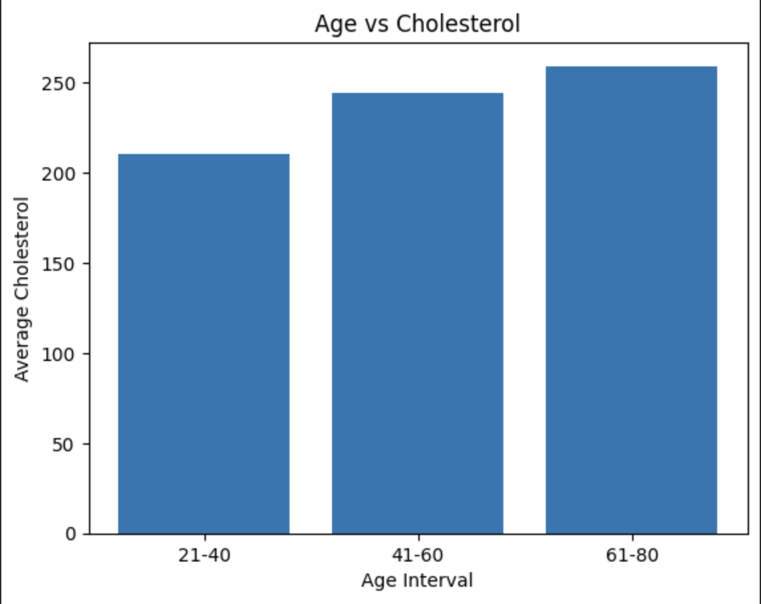
We study the average cholesterol of patients in different age groups. The summary had showed the age range to be 29 to 77, hence we divide the data into three age groups (21-40, 41-60 and 61-80) and visualize their mean cholesterol in a bar graph.

Fig 1:Age vs Cholesterol

- Average thalach (maximum heart rate achieved during exercise) in different age groups
We visualize the maximum heart rate during exercise for patients in the three age groups.
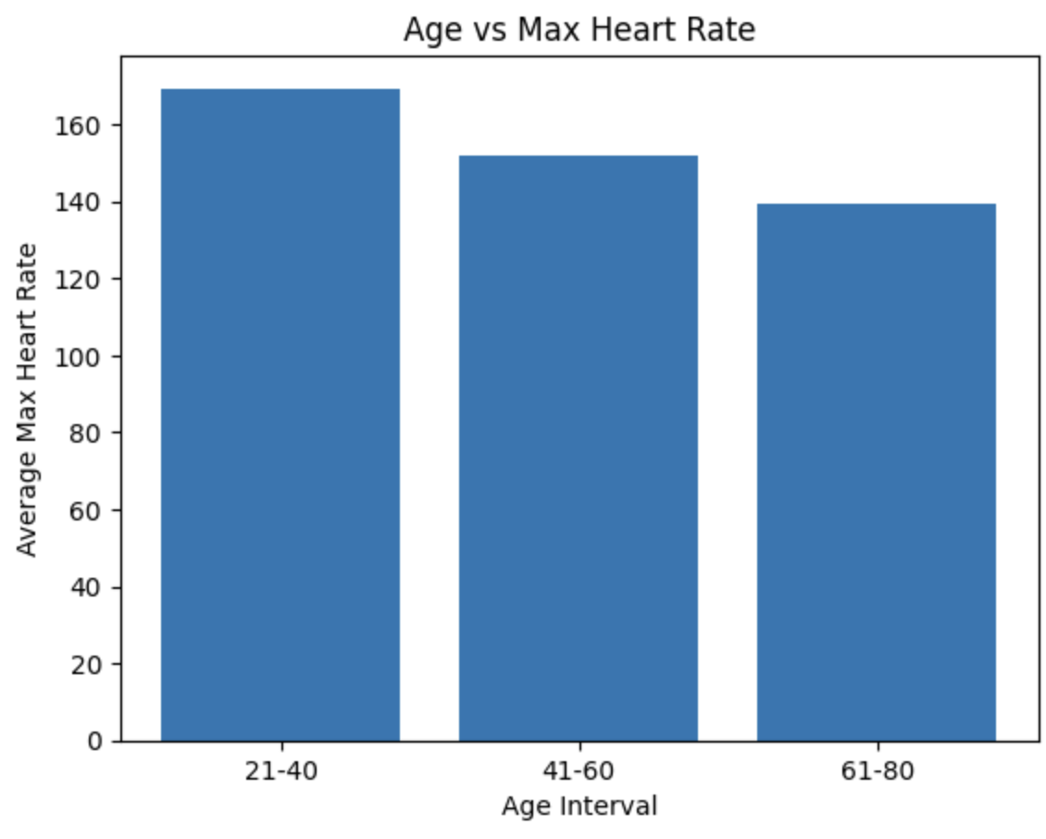
Fig 2:Age vs Max heart rate

It shows a downward trend with age, which matches the expectation. Higher heart rate during exercise indicates a healthier heart. Since people in higher age group have higher cholesterol in our dataset, they might have a less healthier heart, hence this trend makes sense.

- Heart Disease in different Age groups
Here, we visualize the number of people with and without Heart Disease in our dataset in the three age groups.
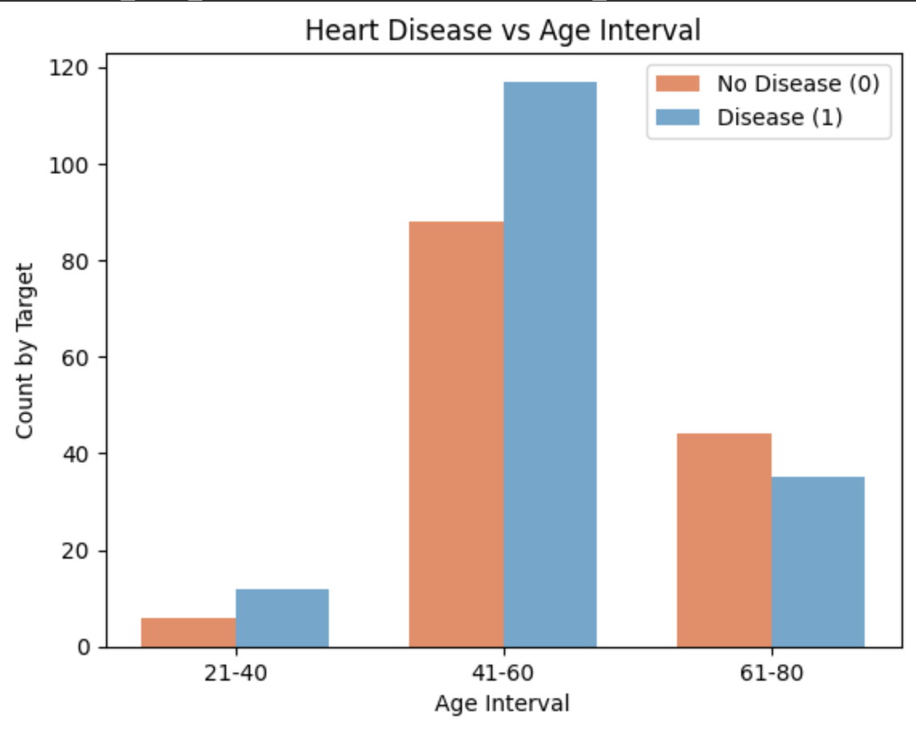

Fig 3: Age vs Heart Disease

We notice that, although average cholesterol is the highest in the oldest age group, due to other health factors, the other two age-groups have more people with heart disease than without it. Among the total number of people present in the middle age group, majority have a heart disease.

- Heart Disease % in different Age groups
To have a better understanding of the previous graph, instead of count we calculate the percentage of people with and without heart disease in each age group.
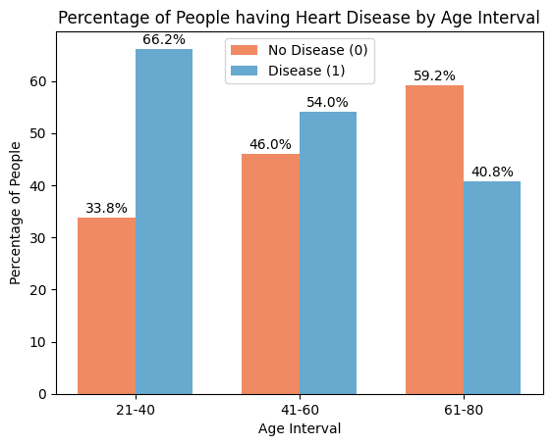

Now we see, almost 66% people in the young age group and 54% people in the middle age group has heart disease.

- Correlation Heatmap
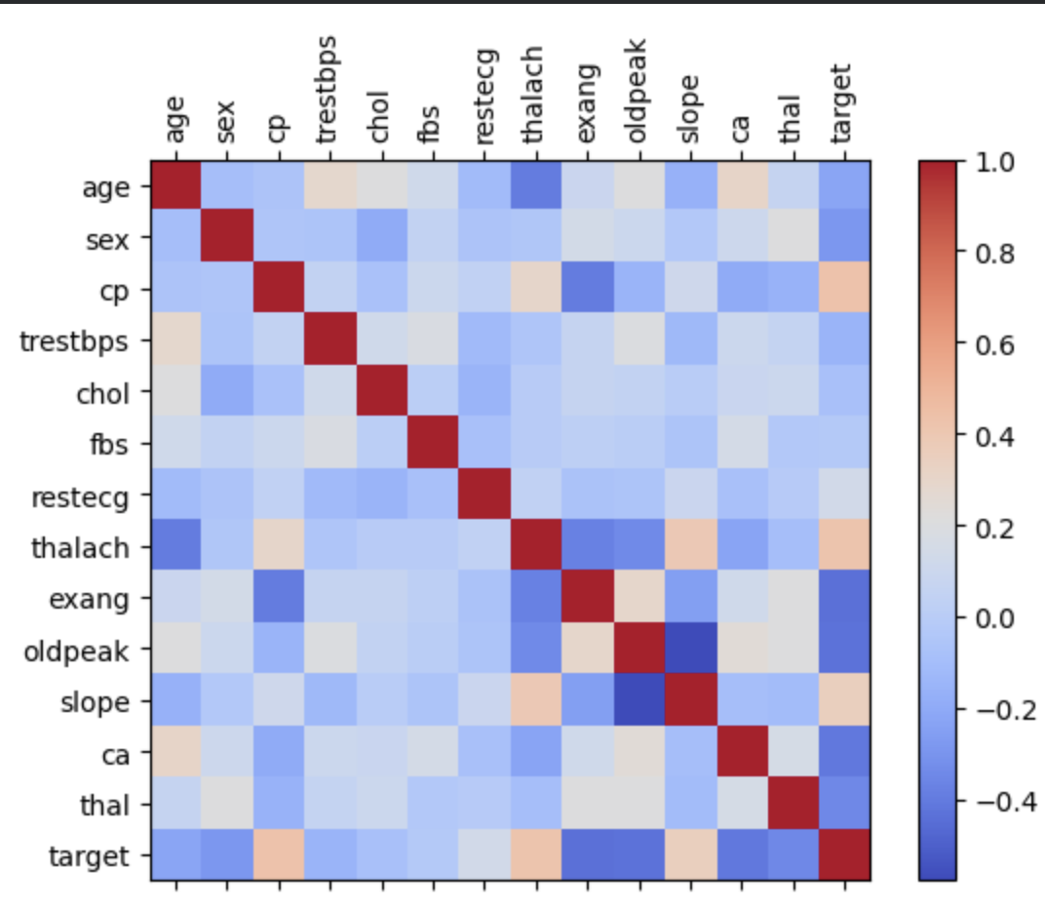
A correlation heatmap was created to visualize the overall relationship of the feature variables among each other.

Fig 4: Correlation matrix visualization

- Gender Distribution
To get an idea about the gender distribution in our dataset, we create a pie chart and find there is 68.2% male patients in our data.
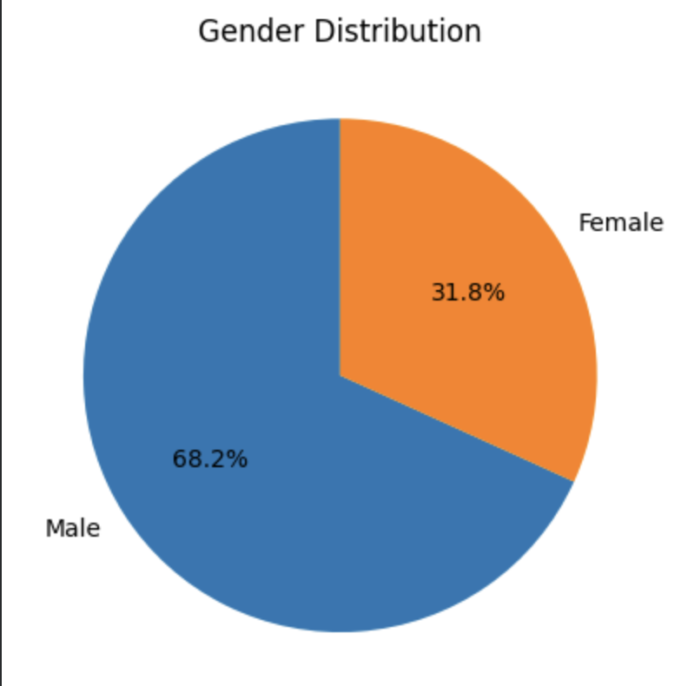
Fig 5: Pie chart for Gender Distribution

- Chest Pain Type Distribution
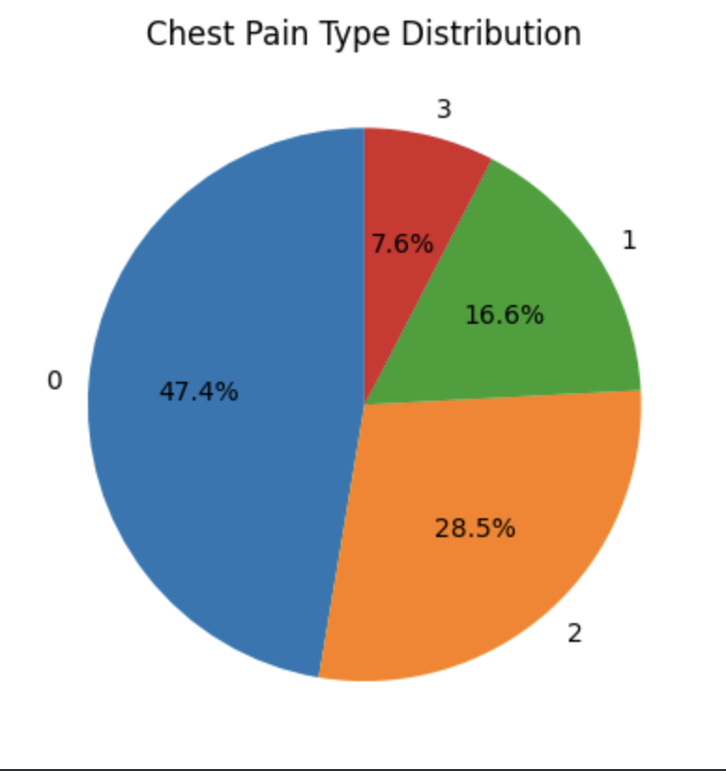
A pie chart of chest pain type shows 52.6% people have experienced chest pain with varied intensity, with 7.6% experiencing a high amount of pain.
Fig 6: Pie Chart for Chest pain type Distribution

- Heart Disease Distribution
45.7% people in our dataset have a heart disease, as revealed by this pie chart.
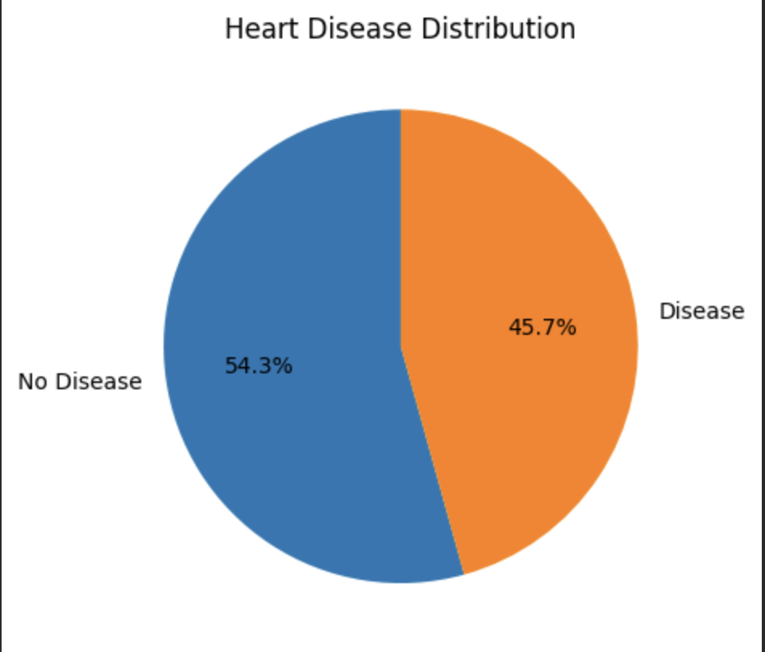

Fig 7: Pie Chart for Heart Disease Distribution

- Gender vs Chest Pain
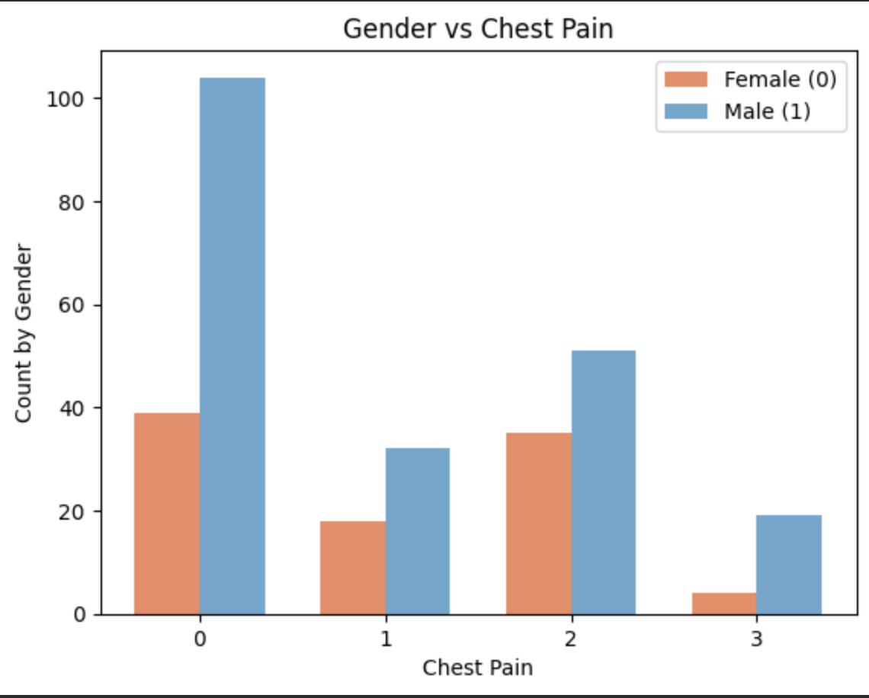
This graph gives a gender-wise distribution for the chest pain type of patients. It shows the count of male and female patients for each type of chest pain intensity experienced by the patients.

Fig 8: Gender vs Chest Pain
- Heart Disease vs Chest Pain
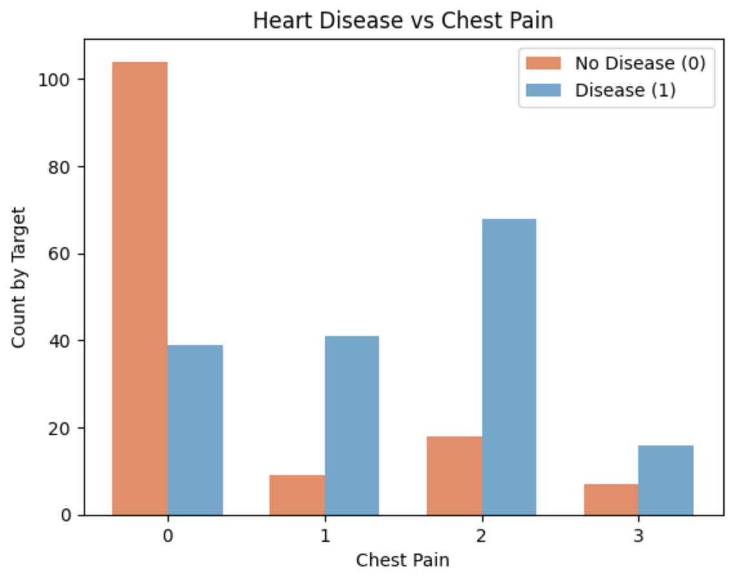
This graph gives an idea of the people with or without heart disease experiencing different levels of chest pain. It shows the count of patients for each type of chest pain intensity, who have the heart disease vs those who do not.
Fig 9: Heart Disease vs Chest Pain

Modelling:
First, we used a Linear Regression Model to predict out target variable.
Linear regression
Feature selection was performed using hypothesis testing with the SelectKBest method, which evaluates the statistical relationship between each input feature and the target variable. For every feature (Xi), the method tests the null hypothesis that there is no correlation between (Xi) and the output (y). It computes a test statistic and associated p-value; features with the lowest p-values are considered more significant and therefore retain stronger predictive power. Based on this evaluation, the top seven most significant features were selected for model training.
After feature selection, the dataset was divided into training and testing subsets using a 70–30 split, ensuring that the model was trained on the majority of the data while reserving a portion for unbiased performance evaluation. A Linear Regression model was then trained on the selected features to predict the target variable. This model learns a best-fit line by minimizing prediction errors on the training data and can then be evaluated on the test set to measure its accuracy and generalization performance.
The R square value of the model comes to be around 0.42. This means only 42% of the variation in dependent variable is being explained by the independent variables in our model. Clearly, the model is not performing well, one reason for which could be that target variable in our data is a binary variable taking values 0 and 1. Hence a more logical fit to our data might be a Logistic Regression Model.
Logistic Regression
Using the same 70–30 train–test split, all available features were used to train a Logistic Regression model. The model achieved an accuracy of 82.5%, indicating a reasonably strong overall predictive performance. The results also show a low Type I error rate, with only 38 false positive cases where the model incorrectly predicted “disease” despite the absence of disease.
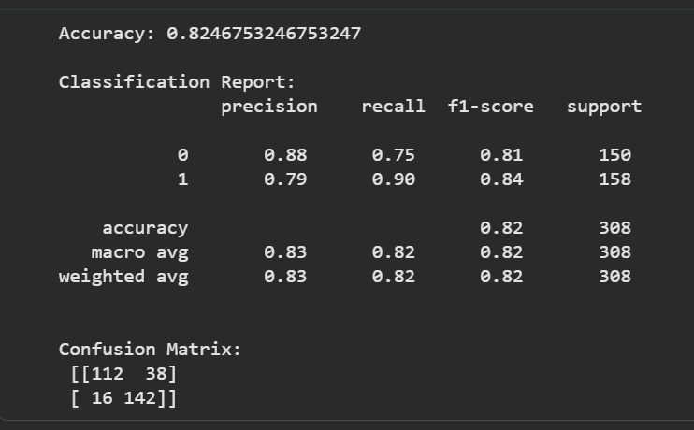
For Class 0 (No Heart Disease), the model demonstrates strong reliability in predicting individuals who are healthy. A precision of 0.88 means that when the model labels a patient as “no disease,” it is correct 88% of the time, showing that very few healthy predictions were incorrect. The recall of 0.75 indicates that out of all the patients who truly did not have heart disease, the model successfully identified 75% of them. However, it missed the remaining 25%, which corresponds to the 38 false positives recorded in the confusion matrix—cases where the model predicted disease even though the patient was actually healthy. The F1-score of 0.81 reflects a good balance between precision and recall, showing that the model maintains dependable performance for identifying non-disease cases while minimizing unnecessary misclassification.
For Class 1 (With Heart Disease), the model performs even more strongly, reflecting its effectiveness in detecting patients who actually require medical attention. The precision of 0.79 means that when the model predicts heart disease, it is correct 79% of the time, although 21% of predictions still turn out to be false alarms. More importantly, the recall score of 0.90 shows that the model successfully identifies 90% of all patients who truly have heart disease. Only 16 false negatives were recorded out of 158 total actual disease cases, meaning the model rarely misses individuals who may need treatment. The F1-score of 0.84 shows that the model is well-balanced and reliable for the positive class, with stronger performance in identifying disease cases than in excluding them.
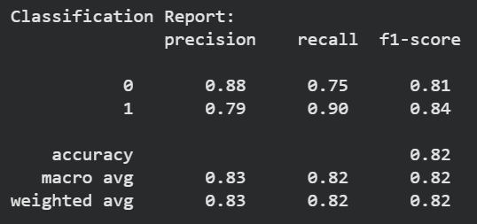
GUI:
To enhance the usability and interpretability of the machine learning model developed in this project, a Graphical User Interface (GUI) was created using Streamlit, a Python framework designed for building interactive web-based applications.
Although both Linear Regression and Logistic Regression were tested in this study, Logistic Regression was ultimately chosen because the prediction task involves a binary outcome determining whether a patient has heart disease (1) or not (0). Linear Regression, which is designed for continuous numerical values, produced outputs outside the 0–1 range and showed weak performance, with an R² value of only 0.42. Logistic Regression, however, is specifically designed for classification problems and uses the sigmoid function to generate meaningful probabilities between 0 and 1, making the predictions easier to interpret and clinically relevant. It also performed significantly better in our analysis, providing higher accuracy and more reliable results, which made it the appropriate choice for this heart disease prediction model.
This interface was designed to demonstrate how the model responds to different clinical inputs and to illustrate its behavior in real-world decision-support scenarios. The GUI allows users to enter patient-specific attributes such as chest pain type, exercise-induced angina, maximum heart rate achieved, ST depression, slope of the ST segment during exercise, the number of major vessels, and thalassemia category. Once the user enters these parameters, the model uses the trained logistic regression decision boundary to classify the patient as either likely to have heart disease (class 1) or unlikely (class 0), along with an associated probability score.
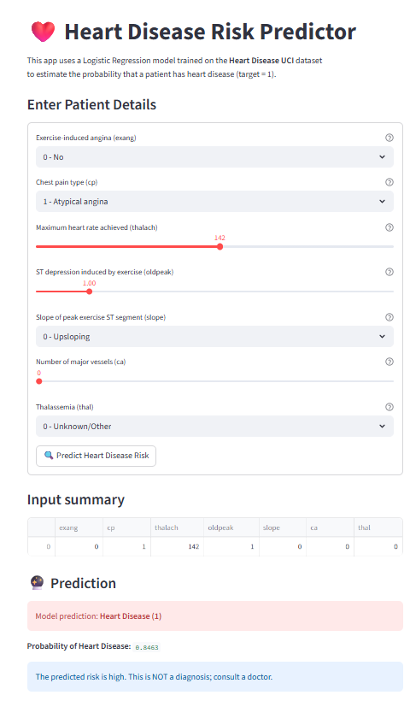
In this example, the user inputs correspond to a higher-risk patient profile, including atypical chest pain, a reduced maximum heart rate of 142, and an ST depression value of 1.0, all of which are factors commonly associated with cardiac stress or abnormal heart function. Although the number of major vessels and thalassemia category appear normal, the overall combination of features resembles patterns found in patients with heart disease in the training dataset. As a result, the model predicts Heart Disease (1) with a high probability of 0.8463, indicating strong confidence in the presence of risk. The interface clearly communicates this by displaying a high-risk warning and advising the user that the result is not a clinical diagnosis but should prompt further medical evaluation.
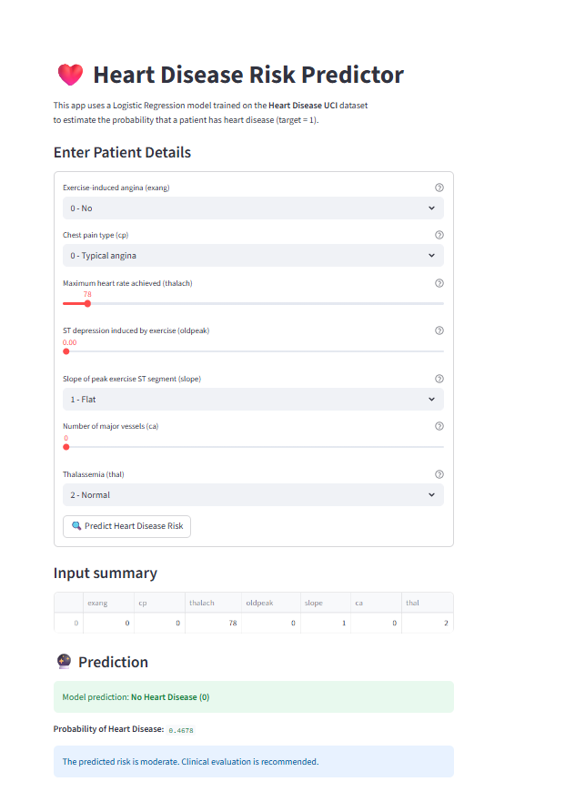
In this scenario, the inputs represent a relatively low-risk cardiac profile. The patient reports no exercise-induced angina, experiences typical chest pain, and shows no ST depression during exercise. Although the maximum heart rate achieved is moderate (78), the slope, number of major vessels, and thalassemia value all fall within normal or non-concerning ranges. Based on this combination of features, the model predicts No Heart Disease (0) with a probability of 0.4678, indicating a moderate but overall lower likelihood of disease. While the risk is not zero, the predicted pattern aligns more closely with individuals who did not have heart disease in the dataset, and the interface appropriately recommends clinical evaluation to ensure proper assessment.

Future work
The current project focuses on a Logistic Regression model. In the future we want to explore more advanced machine learning techniques to potentially improve accuracy, sensitivity, and specificity.
Implement and evaluate other robust classification algorithms such as Random Forest (RF), XGBoost, Support Vector Machines (SVM), or Neural Networks (MLP). The comparative analysis could focus on finding a model that offers a better balance of predictive performance (e.g., higher recall for the "disease" class) and computational efficiency.
Cross-Dataset Validation-Explicitly test the trained Logistic Regression model on multiple, distinct heart disease datasets (as planned in the distinctive approach) to rigorously assess and demonstrate its robustness and generalizability across different patient populations and data collection methodologies.
Integrate the model's output with statistical visualizations (bar charts, histograms) within the GUI. This would allow a user to see an individual's predicted risk level in the context of the overall patient population distribution, making the risk assessment more intuitive and interpretable.

Acknowledgment

We would like to express our sincere gratitude to our professor for the valuable guidance and support throughout the project. Our group members and their respective contributions:

Madhurima Mukhopadhyay and Sarika Thumbapura Arun- created visualizations to analyse relationships among key features such as age, cholesterol, blood pressure and summarized findings for interpretation

Sinchana Datta Pushpa Datta and Shilpa Varadaraju - Focused on data preprocessing and cleaning, ensuring the dataset was consistent and free of missing values before analysis.

Team Work - Contributed to documentation, managed updates across project files, and ensured proper formatting and consistency in the final report.

Our team also made use of AI tool to enhance the quality and efficiency of our work.

Perplexity AI - was used to collect general background information about heart disease, explore factors influencing it, and identify potential datasets for analysis, including the Heart Disease Dataset by David Lapp (Kaggle).

Conclusion

This project explored the development of a Heart Disease Prediction system using machine learning techniques. The dataset was cleaned and preprocessed to ensure reliability, followed by exploratory visualizations that revealed key patterns and relationships among the health indicators. An initial Linear Regression model performed poorly due to the binary nature of the target variable, highlighting the importance of appropriate model selection. To address this, a Logistic Regression model was implemented, which delivered strong and interpretable predictive performance. To make the system accessible to non-technical users, an interactive GUI was built, allowing users to input health parameters and receive intuitive prediction results.

Overall, the project demonstrates a complete pipeline—from data preparation and analysis to modeling and user-friendly deployment—showing how machine learning can assist in early risk identification for heart disease.

References
[1] T. Ashika and G. H. Grace, “Enhancing heart disease prediction with stacked ensemble and MCDM-based ranking: An optimized RST-ML approach,” 2025.
[2] S. M. Ganie and P. K. D. Pramanik, “Ensemble learning with explainable AI for improved heart disease prediction,” 2025.
[3] A. Kumar and S. Dhanka, “A hybrid framework for heart disease prediction using classical and deep learning methods,” 2025.
[4] Y. Mao and B. L. Jimma, “Machine learning algorithms for heart disease diagnosis,” 2025.
[5] M. U. Rehman and S. Naseem, “Predicting coronary heart disease with advanced machine learning algorithms,” 2025.
[6] C.-W. Tseng and L.-C. Sun, “Effectiveness of machine learning models in diagnosis of heart disease: A comparative study,” 2025.
[7] A. A. Ahmad and H. Polat, “Prediction of heart disease based on machine learning using Cleveland dataset,” 2023.
[8] M. I. Bhuiyan, C. H. Wah, N. Shazwani Kamarudin, N. Hafieza Ismail, and A. Fakhri Ab Nasir, “Heart Disease Prediction Using Case-Based Reasoning (CBR),” *Journal of Theoretical and Applied Information Technology*, vol. 102, no. 20, pp. 7275-7285, Oct. 31 2024.
[9] A. Islam, M. A. Saleh, A. F. Tasnim, M. Samiun, S. K. Noor, and K. K. Bishnu, “Identification of Cardiovascular Disease via Diverse Machine Learning Methods,” *Journal of Computer and Communications*, vol. 12, pp. 134-150, Dec. 2024,

